Step by step REST web service test with SOAPUI tool. You don’t need to create a client application to test web service call; you can better use this tool for the same.

1. First down load soapUI from the below url and install it into your computer.

<https://www.soapui.org/downloads/latest-release.html>

1. Open the application and from the file menu select new REST service project and in the window past your url (first example for a GET web service call)

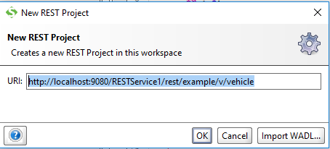

And click ‘OK’

1. Now from project explorer window double click Request1

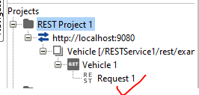

And click the green arrow at the left hand site

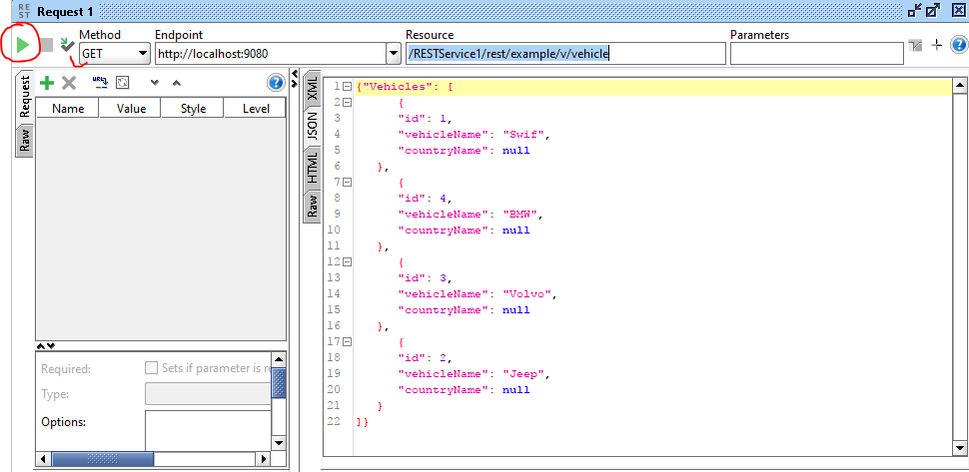

If you need to set some header parameter for your test do it as below:-

Select Header as below:-

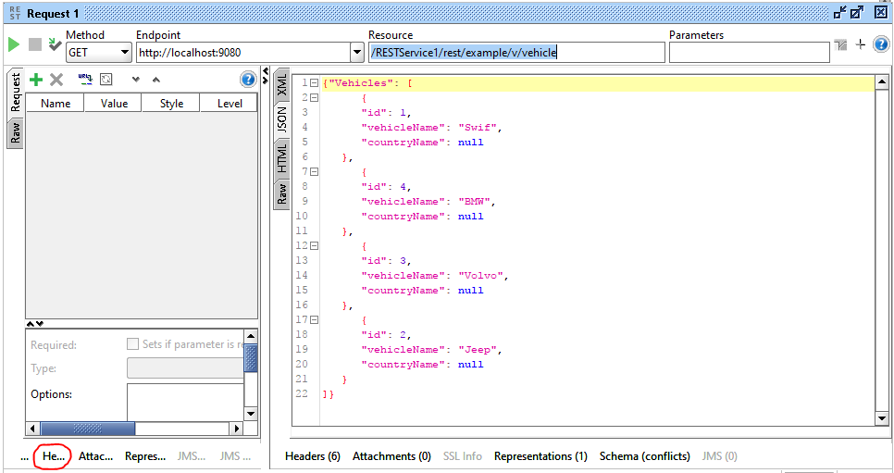

Now click on plus button

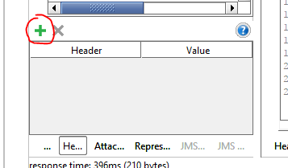

Now add your header parameter as below

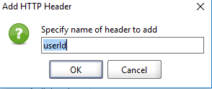

And click ‘OK’ button

Now you can see header parameter ‘userId’ has been added to your project now add value for it

